**Supplementary materialS**

The epidemiology of growth hormone deficiency in adults:

A population-based study in the UK  
**Authors:**

Sherwin Criseno, Emma Gayton, Marzieh Araghi, Serhan Bahit, Andrew Toogood,

**Figure s1: Patient flow diagram for the incidence cohort**

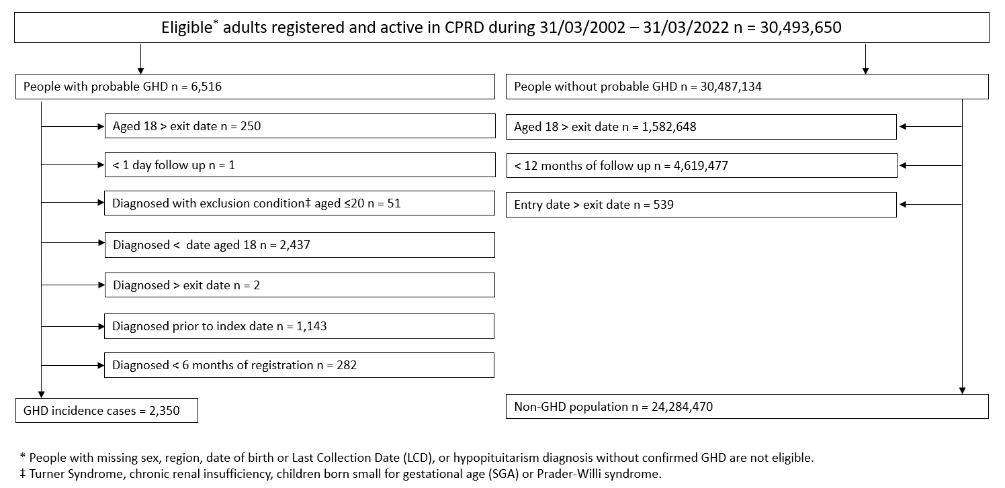

**Table s1: Regional descriptive statistics for the GHD incident cohort at identification**

|  |  |
| --- | --- |
|  | **Incident GHD cases (%)** |
| n | 2,350 |
| Geographical Region n (%) |  |
| North East | 50 (2.1) |
| North West | 493 (21.0) |
| Yorkshire & The Humber | 100 (4.3) |
| East Midlands | 44 (1.9) |
| West Midlands | 334 (14.2) |
| East of England | 122 (5.2) |
| London | 267 (11.4) |
| South Central | 436 (18.6) |
| South West | 494 (21.0) |
| Scotland | 10 (0.4) |

**Table s2: Temporal trend in the incidence of GHD over the twenty-year study period**

| **Year** | **GHD cases n** | **Person years** | **Incidence per 100,000 person years (95% CI)** |
| --- | --- | --- | --- |
| 2002-2006 | 994 | 95,933,190 | 1.04 (0.97, 1.10) |
| 2007-2011 | 619 | 50,613,120 | 1.22 (1.13, 1.32) |
| 2012-2017 | 403 | 29,918,030 | 1.35 (1.22, 1.49) |
| 2018-2022 | 334 | 17,928,780 | 1.86 (1.67, 2.07) |

**Table s3: Incidence of GHD by demographic and clinical subgroups**

|  |  |  |  |  |
| --- | --- | --- | --- | --- |
| **Subgroup** | **GHD**  **cases** | **Person-years** | **Incidence rate per 100,000 person-years (95%CI)** | **Adjusted Incidence Rate Ratioa**  **(95%CI)** |
| Overall | 2,350 | 194,392,020 | 1.21 (1.16, 1.26) |  |
| Sex |  |  |  |  |
| Male | 1,289 | 96,796,498 | 1.33 (1.26, 1.41) | 1.0 (reference) |
| Female | 1,061 | 97,595,522 | 1.09 (1.02, 1.16) | 0.67 (0.62, 0.73) |
| Age group |  |  |  |  |
| 18-19 | 33 | 21,234,800 | 0.16 (0.11, 0.22) | 0.30 (0.21, 0.44) |
| 20-29 | 181 | 36,992,983 | 0.49 (0.42, 0.57) | 1.0 (reference) |
| 30-39 | 263 | 43,076,122 | 0.61 (0.54, 0.69) | 1.17 (0.97, 1.41) |
| 40-49 | 371 | 33,455,845 | 1.11 (1.00, 1.23) | 2.03 (1.70, 2.43) |
| 50-59 | 435 | 26,556,951 | 1.64 (1.49, 1.80) | 2.88 (2.42, 3.43) |
| 60-69 | 465 | 18,004,457 | 2.58 (2.35, 2.83) | 4.23 (3.55, 5.03) |
| 70-79 | 409 | 10,405,939 | 3.93 (3.56, 4.33) | 6.36 (5.33, 7.59) |
| 80+ | 193 | 4,664,922 | 4.14 (3.57, 4.76) | 7.72 (6.29, 9.48) |
| Ethnicity |  |  |  |  |
| White | 1,844 | 114,957,258 | 1.60 (1.53, 1.68) | 1.0 (reference) |
| South Asian | 143 | 6,834,729 | 2.09 (1.76, 2.47) | 1.73 (1.45, 2.07) |
| Black | 135 | 4,661,766 | 2.90 (2.43, 3.43) | 2.23 (1.85, 2.70) |
| Other | 48 | 3,106,589 | 1.55 (1.14, 2.05) | 1.23 (0.92, 1.65) |
| Mixed | 23 | 1,174,635 | 1.96 (1.24, 2.94) | 1.97 (1.31, 2.99) |
| Not recorded | 157 | 63,657,044 | 0.25 (0.21, 0.29) | 0.16 (0.13, 0.20) |
| Deprivation |  |  |  |  |
| 1 (least deprived) | 448 | 38,989,246 | 1.15 (1.05, 1.26) | 0.89 (0.77, 1.02) |
| 2 | 500 | 38,918,622 | 1.29 (1.18, 1.40) | 1.00 (0.88, 1.14) |
| 3 | 442 | 37,011,472 | 1.19 (1.09, 1.31) | 0.94 (0.83, 1.08) |
| 4 | 469 | 38,382,975 | 1.22 (1.11, 1.34) | 0.98 (0.86, 1.12) |
| 5 (most deprived) | 434 | 35,064,259 | 1.24 (1.12, 1.36) | 1.0 (reference) |
| Not recorded | 57 | 6,025,447 | 0.95 (0.72, 1.23) | 3.10 (2.22, 4.32) |
| Geographical region |  |  |  |  |
| North East | 50 | 6,135,920 | 0.82 (0.61, 1.07) | 0.69 (0.51, 0.94) |
| North West | 493 | 35,647,698 | 1.38 (1.26, 1.51) | 1.22 (1.05, 1.42) |
| Yorkshire & The Humber | 100 | 6,999,187 | 1.43 (1.16, 1.74) | 1.33 (1.06, 1.67) |
| East Midlands | 44 | 4,825,702 | 0.91 (0.66, 1.22) | 0.92 (0.67, 1.27) |
| West Midlands | 334 | 30,621,750 | 1.09 (0.98, 1.21) | 0.92 (0.78, 1.08) |
| East of England | 122 | 8,338,601 | 1.46 (1.22, 1.75) | 1.29 (1.04, 1.60) |
| London | 267 | 23,395,151 | 1.14 (1.01, 1.29) | 1.0 (reference) |
| South Central | 436 | 39,675,843 | 1.10 (1.00, 1.21) | 1.04 (0.89, 1.21) |
| South West | 494 | 37,951,897 | 1.30 (1.19, 1.42) | 1.24 (1.06, 1.45) |
| Scotland | 10 | 800,271 | 1.25 (0.60, 2.30) | 2.12 (1.06, 4.25) |

aAdjusted for sex, age at study entry date, deprivation, region, ethnicity.

Figure s2: Patient flow diagram for the prevalence cohort

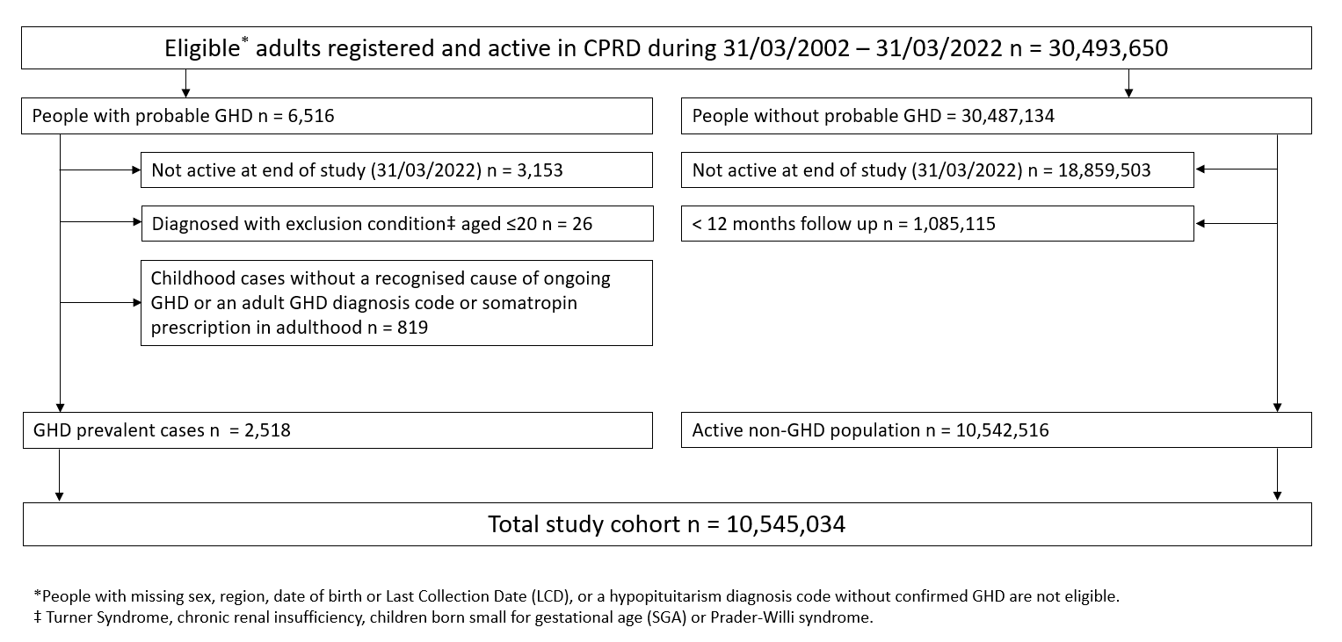

Table s4: Baseline characteristics of the GHD prevalent cohort

|  | **Prevalent GHD cases** |
| --- | --- |
| n | 2,518 |
| Age at identification (median [IQR]) | 45.0 [22.8, 59.9] |
| Current age at point prevalence (median [IQR]) | 56.2 [38.3, 70.3] |
| Sex n (%) |  |
| Male | 1,385 (55.0) |
| Female | 1,133 (45.0) |
| Age group n (%) |  |
| 18-19 | 55 (2.2) |
| 20-29 | 313 (12.4) |
| 30-39 | 334 (13.3) |
| 40-49 | 324 (12.9) |
| 50-59 | 404 (16.0) |
| 60-69 | 455 (18.1) |
| 70-79 | 414 (16.4) |
| 80+ | 219 (8.7) |
| Ethnicity n (%) |  |
| White | 1,812 (72.0) |
| South Asian | 154 (6.1) |
| Black | 141 (5.6) |
| Other | 50 (2.0) |
| Mixed | 27 (1.1) |
| Not recorded | 334 (13.3) |
| Deprivation n (%) |  |
| 1 (least deprived) | 482 (19.1) |
| 2 | 483 (19.2) |
| 3 | 450 (17.9) |
| 4 | 483 (19.2) |
| 5 (most deprived) | 439 (17.4) |
| Not recorded | 181 (7.2) |
| Geographical Region n (%) |  |
| North East | 66 (2.6) |
| North West | 536 (21.3) |
| Yorkshire & The Humber | 99 (3.9) |
| East Midlands | 63 (2.5) |
| West Midlands | 345 (13.7) |
| East of England | 120 (4.8) |
| London | 271 (10.8) |
| South Central | 479 (19.0) |
| South West | 526 (20.9) |
| Scotland | 13 (0.5) |

IQR, inter quartile range

Table s5: Point prevalence for identified GHD

|  |  |  |  |
| --- | --- | --- | --- |
|  | **GHD cases** | **Total** | **Point prevalence**  **(95% CI)** |
| Overall | 2,518 | 10,545,034 | 0.024 (0.023, 0.025) |
| Sex |  |  |  |
| Male | 1,385 | 5,296,410 | 0.026 (0.025, 0.028) |
| Female | 1,133 | 5,248,624 | 0.022 (0.020, 0.023) |
| Age group |  |  |  |
| 18-19 | 55 | 283,808 | 0.019 (0.015, 0.025) |
| 20-29 | 313 | 1,635,952 | 0.019 (0.017, 0.021) |
| 30-39 | 334 | 1,923,251 | 0.017 (0.016, 0.019) |
| 40-49 | 324 | 1,765,161 | 0.018 (0.016, 0.020) |
| 50-59 | 404 | 1,803,372 | 0.022 (0.020, 0.025) |
| 60-69 | 455 | 1,404,707 | 0.032 (0.030, 0.036) |
| 70-79 | 414 | 1,069,568 | 0.039 (0.035, 0.043) |
| 80+ | 219 | 659,215 | 0.033 (0.029, 0.038) |
| Ethnicity |  |  |  |
| White | 1,812 | 5,635,008 | 0.032 (0.031, 0.034) |
| South Asian | 154 | 429,958 | 0.036 (0.030, 0.042) |
| Black | 141 | 275,159 | 0.051 (0.043, 0.061) |
| Other | 50 | 194,541 | 0.026 (0.019, 0.034) |
| Mixed | 27 | 79,323 | 0.034 (0.023, 0.050) |
| Not recorded | 334 | 3,931,045 | 0.008 (0.008, 0.009) |
| Deprivation |  |  |  |
| 1 (least deprived) | 482 | 2,057,889 | 0.023 (0.021, 0.026) |
| 2 | 483 | 2,082,135 | 0.023 (0.021, 0.025) |
| 3 | 450 | 2,026,414 | 0.022 (0.020, 0.024) |
| 4 | 483 | 2,163,263 | 0.022 (0.020, 0.024) |
| 5 (most deprived) | 439 | 1,964,128 | 0.022 (0.020, 0.025) |
| Not recorded | 181 | 251,205 | 0.072 (0.062, 0.084) |
| Geographical region |  |  |  |
| North East | 66 | 327,808 | 0.020 (0.016, 0.026) |
| North West | 536 | 1,860,354 | 0.029 (0.026, 0.031) |
| Yorkshire & The Humber | 99 | 395,910 | 0.025 (0.020, 0.031) |
| East Midlands | 63 | 273,680 | 0.023 (0.018, 0.030) |
| West Midlands | 345 | 1,661,550 | 0.021 (0.019, 0.023) |
| East of England | 120 | 465,826 | 0.026 (0.021, 0.031) |
| London | 271 | 1,236,108 | 0.022 (0.019, 0.025) |
| South Central | 479 | 2,084,347 | 0.023 (0.021, 0.025) |
| South West | 526 | 2,191,115 | 0.024 (0.022, 0.026) |
| Scotland | 13 | 48,336 | 0.027 (0.015, 0.047) |

**Figure s3: Time since GHD identification and percentage initiating somatropin treatment**

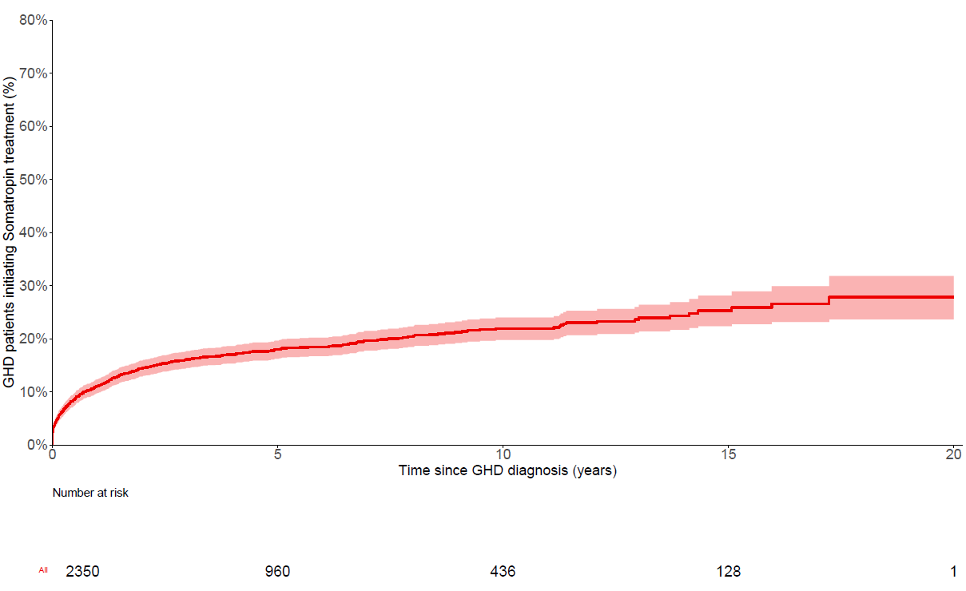

**Figure s4: Persistence of GHD somatropin treatment, based on 194 day interval (90th centile) threshold**

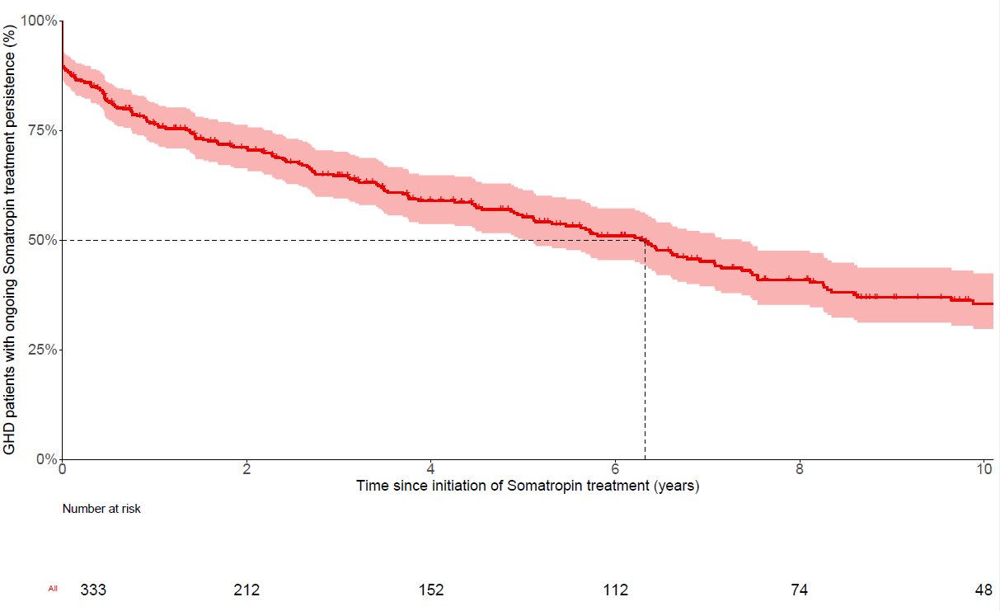

**Table s6: Incidence of GHD by demographic and clinical subgroups, using the broader GHD case definition**

|  |  |  |  |  |
| --- | --- | --- | --- | --- |
| **Subgroup** | **GHD cases** | **Person-years** | **Incidence rate per 100,000 person-years (95%CI)** | **Adjusted Incidence Rate Ratioa (95%CI)** |
| Overall | 4,202 | 194,405,121 | 2.16 (2.10, 2.23) |  |
| Sex |  |  |  |  |
| Male | 2,206 | 96,803,518 | 2.28 (2.19, 2.38) | 1.0 (reference) |
| Female | 1,996 | 97,601,603 | 2.05 (1.96, 2.14) | 0.74 (0.70, 0.79) |
| Age group |  |  |  |  |
| 18-19 | 61 | 21,234,825 | 0.29 (0.22, 0.37) | 0.29 (0.22, 0.38) |
| 20-29 | 356 | 36,993,641 | 0.96 (0.87, 1.07) | 1.0 (reference) |
| 30-39 | 534 | 43,077,553 | 1.24 (1.14, 1.35) | 1.22 (1.07, 1.40) |
| 40-49 | 679 | 33,458,056 | 2.03 (1.88, 2.19) | 1.94 (1.70, 2.20) |
| 50-59 | 801 | 26,559,696 | 3.02 (2.81, 3.23) | 2.78 (2.45, 3.15) |
| 60-69 | 775 | 18,007,023 | 4.30 (4.01, 4.62) | 3.71 (3.27, 4.22) |
| 70-79 | 670 | 10,408,204 | 6.44 (5.96, 6.94) | 5.47 (4.81, 6.24) |
| 80+ | 326 | 4,666,124 | 6.99 (6.25, 7.79) | 6.74 (5.79, 7.84) |
| Ethnicity |  |  |  |  |
| White | 3,237 | 114,967,381 | 2.82 (2.72, 2.91) | 1.0 (reference) |
| South Asian | 258 | 6,835,524 | 3.78 (3.33, 4.26) | 1.68 (1.47, 1.91) |
| Black | 236 | 4,662,366 | 5.06 (4.44, 5.75) | 2.06 (1.78, 2.37) |
| Other | 84 | 3,106,808 | 2.70 (2.16, 3.35) | 1.15 (0.92, 1.43) |
| Mixed | 49 | 1,174,814 | 4.17 (3.09, 5.51) | 2.25 (1.69, 2.99) |
| Not recorded | 338 | 63,658,228 | 0.53 (0.48, 0.59) | 0.20 (0.18, 0.23) |
| Deprivation |  |  |  |  |
| 1 (least deprived) | 802 | 38,991,919 | 2.06 (1.92, 2.20) | 0.86 (0.78, 0.95) |
| 2 | 828 | 38,920,915 | 2.13 (1.99, 2.28) | 0.89 (0.81, 0.98) |
| 3 | 791 | 37,014,082 | 2.14 (1.99, 2.29) | 0.91 (0.82, 1.00) |
| 4 | 850 | 38,385,430 | 2.21 (2.07, 2.37) | 0.94 (0.85, 1.04) |
| 5 (most deprived) | 823 | 35,066,966 | 2.35 (2.19, 2.51) | 1.0 (reference) |
| Not recorded | 108 | 6,025,809 | 1.79 (1.47, 2.16) | 2.73 (2.15, 3.46) |
| Geographical region |  |  |  |  |
| North East | 109 | 6,136,338 | 1.78 (1.46, 2.14) | 0.94 (0.76, 1.15) |
| North West | 924 | 35,650,870 | 2.59 (2.43, 2.76) | 1.42 (1.27, 1.59) |
| Yorkshire & The Humber | 162 | 6,999,626 | 2.31 (1.97, 2.70) | 1.34 (1.12, 1.61) |
| East Midlands | 82 | 4,826,019 | 1.70 (1.35, 2.11) | 1.07 (0.85, 1.36) |
| West Midlands | 586 | 30,623,559 | 1.91 (1.76, 2.08) | 1.00 (0.89, 1.14) |
| East of England | 204 | 8,339,155 | 2.45 (2.12, 2.81) | 1.35 (1.15, 1.60) |
| London | 427 | 23,396,292 | 1.83 (1.66, 2.01) | 1.0 (reference) |
| South Central | 767 | 39,678,178 | 1.93 (1.80, 2.08) | 1.14 (1.01, 1.28) |
| South West | 925 | 37,954,766 | 2.44 (2.28, 2.60) | 1.45 (1.28, 1.63) |
| Scotland | 16 | 800,318 | 2.00 (1.14, 3.25) | 1.84 (1.07, 3.16) |

aAdjusted for sex, age at study entry date, deprivation, region, ethnicity.

**Table s7: Point prevalence for identified GHD, using the broader GHD case definition**

|  |  |  |  |
| --- | --- | --- | --- |
|  | **GHD cases** | **Total** | **Point prevalence**  **(95% CI)** |
| Overall | 4,869 | 10,547,385 | 0.046 (0.045, 0.047) |
| Sex |  |  |  |
| Male | 2,531 | 5,297,556 | 0.048 (0.046, 0.050) |
| Female | 2,338 | 5,249,829 | 0.045 (0.043, 0.046) |
| Age group |  |  |  |
| 18-19 | 81 | 283,834 | 0.029 (0.023, 0.036) |
| 20-29 | 489 | 1,636,128 | 0.030 (0.027, 0.033) |
| 30-39 | 620 | 1,923,537 | 0.032 (0.030, 0.035) |
| 40-49 | 688 | 1,765,525 | 0.039 (0.036, 0.042) |
| 50-59 | 832 | 1,803,800 | 0.046 (0.043, 0.049) |
| 60-69 | 932 | 1,405,184 | 0.066 (0.062, 0.071) |
| 70-79 | 790 | 1,069,944 | 0.074 (0.069, 0.079) |
| 80+ | 437 | 659,433 | 0.066 (0.060, 0.073) |
| Ethnicity |  |  |  |
| White | 3,372 | 5,636,568 | 0.060 (0.058, 0.062) |
| South Asian | 309 | 430,113 | 0.072 (0.064, 0.080) |
| Black | 279 | 275,297 | 0.101 (0.090, 0.114) |
| Other | 103 | 194,594 | 0.053 (0.043, 0.064) |
| Mixed | 60 | 79,356 | 0.076 (0.058, 0.098) |
| Not recorded | 746 | 3,931,457 | 0.019 (0.018, 0.020) |
| Deprivation |  |  |  |
| 1 (least deprived) | 896 | 2,058,303 | 0.044 (0.041, 0.047) |
| 2 | 891 | 2,082,543 | 0.043 (0.040, 0.046) |
| 3 | 896 | 2,026,860 | 0.044 (0.041, 0.047) |
| 4 | 937 | 2,163,717 | 0.043 (0.041, 0.046) |
| 5 (most deprived) | 886 | 1,964,575 | 0.045 (0.042, 0.048) |
| Not recorded | 363 | 251,387 | 0.144 (0.130, 0.160) |
| Geographical region |  |  |  |
| North East | 135 | 327,877 | 0.041 (0.035, 0.049) |
| North West | 988 | 1,860,806 | 0.053 (0.050, 0.057) |
| Yorkshire & The Humber | 198 | 396,009 | 0.050 (0.043, 0.058) |
| East Midlands | 113 | 273,730 | 0.041 (0.034, 0.050) |
| West Midlands | 661 | 1,661,866 | 0.040 (0.037, 0.043) |
| East of England | 234 | 465,940 | 0.050 (0.044, 0.057) |
| London | 532 | 1,236,369 | 0.043 (0.039, 0.047) |
| South Central | 939 | 2,084,807 | 0.045 (0.042, 0.048) |
| South West | 1,050 | 2,191,639 | 0.048 (0.045, 0.051) |
| Scotland | 19 | 48,342 | 0.039 (0.024, 0.063) |